**FUNCTIONAL SKILLS ENGLISH**

**Fast Track**

This course leads to a nationally recognised qualification in Functional Skills English at Level 1 or Level 2 from the exam board Pearson Edexcel.

Gateshead Council’s Fast Track English course involves a mix of face-to-face learning and online learning.

All allocated work is personalised based on initial and diagnostic assessments which are completed during the induction session.

Learning is supported via one-to-one tutor catch up appointments; tutors can schedule telephone calls and Google Meet video calls at different times in the week to suit learners.

Some of the topics covered include:

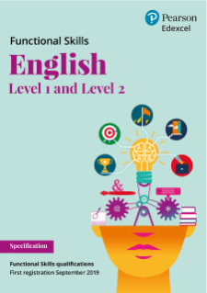

**Reading**

* Purpose of text
* Organisational features and language techniques
* Reading for information

**Writing**

* Developing punctuation
* Writing for different purposes
* Organising writing

**Speaking and Listening**

* Group discussion skills
* Presentation skills
* Question and answer skills.

**Google Classroom**

Google Classroom is used as both a learning tool and a communication platform. Work is assigned and marked by your tutor. 

You will need a Google account to use Google Classroom. You can use your personal account, create a new account for free or ask your tutor to create an account for you.

Access using the following link or class code:

**Link:**

**Class code:**

**Timetable**

| **Session and mode** | **Location** | **Day** | **Date** | **Time** |
| --- | --- | --- | --- | --- |
| Induction and diagnostic assessment | **Interchange Centre** | Fri | 02/06/23 | 9:30-12:30 |
| Induction paperwork and self study | **Online: Google Classroom**  Use Google Classroom to complete the induction paperwork and the work set by your tutor.  NB: you MUST complete your ILP and the self study review | No attendance but tutor catch up slots can be booked. This week’s tutors:  [lucieglanville@gateshead.gov.uk](mailto:lucieglanville@gateshead.gov.uk) | | |
| Taught Session (face-to-face) | **Interchange Centre**  (tutor - Lucie Glanville) | Fri | 09/06/23 | 9.30-11:30 and 12:30-14:30 |
| Self study | **Online: Google Classroom**  Use Google Classroom to complete the work set by your tutor.  NB: you MUST complete your ILP and the self study review | No attendance but tutor catch up slots can be booked. This week’s tutors:  [lucieglanville@gateshead.gov.uk](mailto:lucieglanville@gateshead.gov.uk) | | |
| Exam Session  (Speaking and Listening) | **Online: Google Meet** | Fri | 16/06/23 | 1 hour slot - exact times to be decided by the group |
| Taught Session (face-to-face) | **Interchange Centre**  (tutor - Lucie Glanville) | Fri | 23/06/23 | 9:30-12:30 and  13:00-15:30  (mock exams) |
| Exam Session (Reading and Writing) | **Headworks, Civic Centre**  (Assessor: Sarah Richardson) | Fri | 30/06/23 | 9:30-12:00 |

**Exams:**

| **Exam** | **Information** |
| --- | --- |
| Speaking and listening | Approx 1 hour with 2-3 other learners; online or in-person. |
| Reading | 1 hour 15 mins.  Approx 15 questions based on 3 texts. Dictionary permitted. |
| Writing | 1 hour.  2 writing tasks. Dictionary NOT permitted. |

Reading and Writing exams are usually taken in the same session but can be taken separately where required. It is possible to re-sit only one paper if required.

**Marking and feedback:**

Feedback, in both verbal and written forms, is a fundamental part of your learning journey. We aim to return your work to you in a timely fashion and provide appropriate ongoing assessment.

Please allow up to 1 week for your marked work to be returned to you (except for mock exams completed on 23/06/23, which will be marked on 26/06/22 to establish exam readiness for 30/06/23).

**English tutor contact details**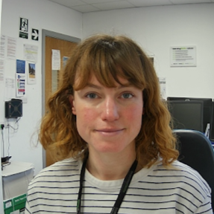

**Name:** Lucie Glanville

**Telephone:** 0191 433 8535 or 07756339885

**Email:** [lucieglanville@gateshead.gov.uk](mailto:lucieglanville@gateshead.gov.uk)

**Postal address**: Learning and Skills, Gateshead Council, Civic Centre, Regent Street, Gateshead, NE8 1HH